ASTANA IT UNIVERSITY
Laboratory Report
Sensors for IoT
Precision Agriculture Monitoring System
"AquaGuard"
Authors:
Kanatova Dariya
Assyrzhanova Gaukhar
Group: IIoT-2401
Astana, 2026

1. Abstract
This report describes the development and testing of AquaGuard, an IoT-based Precision Agriculture Monitoring System. The prototype integrates soil moisture, temperature, humidity, and illuminance sensors on an ESP32 microcontroller. Sensor data is transmitted via MQTT to a ThingsBoard cloud dashboard. An automated rule-based irrigation algorithm activates a water pump when soil moisture exceeds the dry threshold and suppresses irrigation when rain is forecast, achieving water-efficient automated crop management. Testing in the Wokwi simulation environment confirmed correct behaviour across all test scenarios.

2. Introduction
Traditional irrigation relies on fixed schedules rather than real-time soil conditions, leading to overwatering and water waste -a critical concern in arid regions such as Kazakhstan. Precision agriculture, enabled by IoT sensor networks, allows data-driven irrigation decisions that align water delivery with actual crop demand (Ahmed et al., 2018).
This project implements a low-cost ESP32-based monitoring station that collects multi-parameter environmental data, visualises it on a ThingsBoard dashboard, and applies an automated irrigation logic including a predictive rain-forecast feature. The prototype directly supports Kazakhstan's agricultural digitalisation goals (Baydildina et al., 2020).
Objectives
- Monitor soil moisture at two simulated depths using capacitive sensor proxies.
- Measure ambient temperature, humidity, and illuminance.
- Transmit telemetry to ThingsBoard via MQTT over Wi-Fi.
- Implement and validate an automated irrigation decision algorithm.
- Evaluate system behaviour under simulated field conditions.

3. System Architecture
The system is organised into three layers: Data Acquisition (sensors), Edge Processing (ESP32), and Cloud Visualisation (ThingsBoard). Sensor data is sampled every 3 seconds, with MQTT telemetry published every 5 seconds. Critical events trigger Telegram Bot notifications via HTTPS.
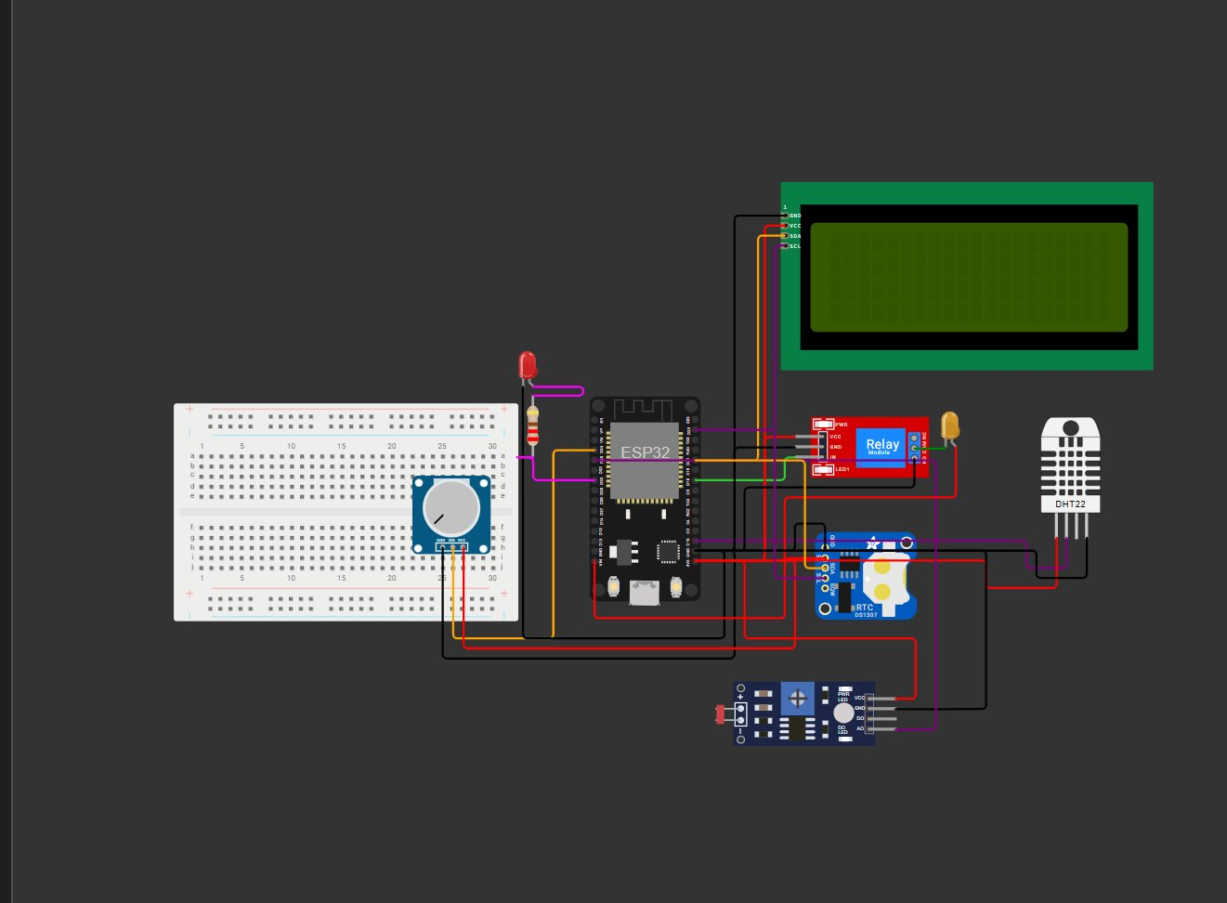
Figure 1. AquaGuard Wokwi simulation circuit -ESP32 connected to DHT22, potentiometer (soil sensor), LDR, relay, LCD2004, DS1307 RTC, LED, and push button

4. Hardware Implementation
Table 1 summarises all hardware components used in the prototype.
Table 1. Bill of Materials
Component | Model | Pin | Purpose
Microcontroller | ESP32 DevKit V1 | — | Processing, Wi-Fi, MQTT
Soil moisture ×2 | Capacitive / pot | D34, D35 | Volumetric water content
Temp & humidity | DHT22 | D15 | Air temperature and RH
Light sensor | LDR (BH1750 target) | D35 | Illuminance measurement
RTC module | DS1307 | D21/D22 | Telemetry timestamps
Relay module | 5 V single channel | D18 | Controls water pump
LCD display | LCD2004 I2C 20×4 | D21/D22 | Local status readout
Rain forecast button | Tactile push button | D4 | Simulates rain input

Sensor Selection: Capacitive vs. Resistive
Capacitive soil moisture sensors measure the dielectric constant of soil rather than passing current through metal probes. This eliminates electrolytic corrosion -the dominant failure mode of resistive sensors -and produces consistent output in saline soils typical of irrigated fields. In this prototype, potentiometers simulate the analogue voltage output of capacitive probes. In field deployment, FC-28 or FDR probes would be used (Zhang et al., 2010).

5. Software and Data Processing
The firmware is written in C++ (Arduino framework) and runs on the ESP32. Key libraries include PubSubClient for MQTT, LiquidCrystal_I2C for the LCD, DHT for sensor reading, RTClib for timestamps, and HTTPClient for Telegram alerts. Telemetry is serialised as a JSON object containing eight keys: temperature, humidity, soil_moisture, light_lux, pump_active, led_active, rain_forecast, and rain_prob, and published to ThingsBoard topic v1/devices/me/telemetry every 5 seconds (Ahmed et al., 2018).
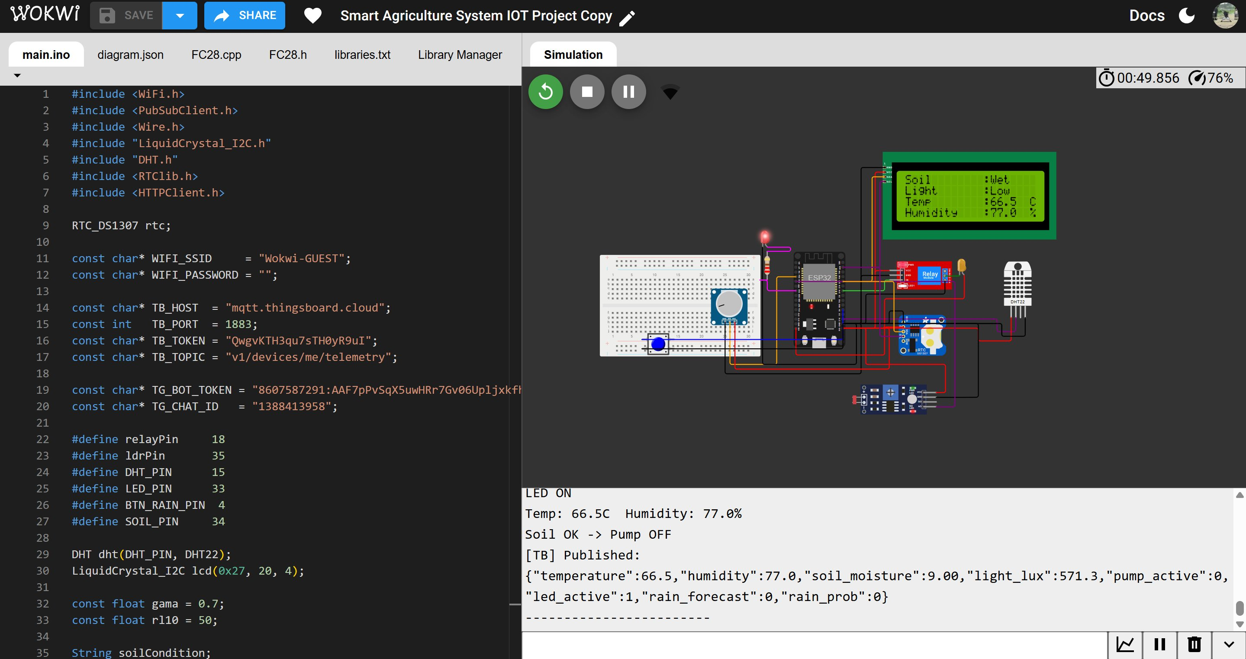
Figure 2. Wokwi normal monitoring state -LCD showing Soil: Wet, Light: Low, Temp: 66.5 °C, Humidity: 77.0%. Serial monitor confirms [TB] Published telemetry.
ThingsBoard Dashboard
The ThingsBoard dashboard displays four analogue gauge widgets (temperature, humidity, soil moisture, light), a time-series line chart, a latest-telemetry attributes card, and pump/LED status cards. Data appears in real time as MQTT messages are received.
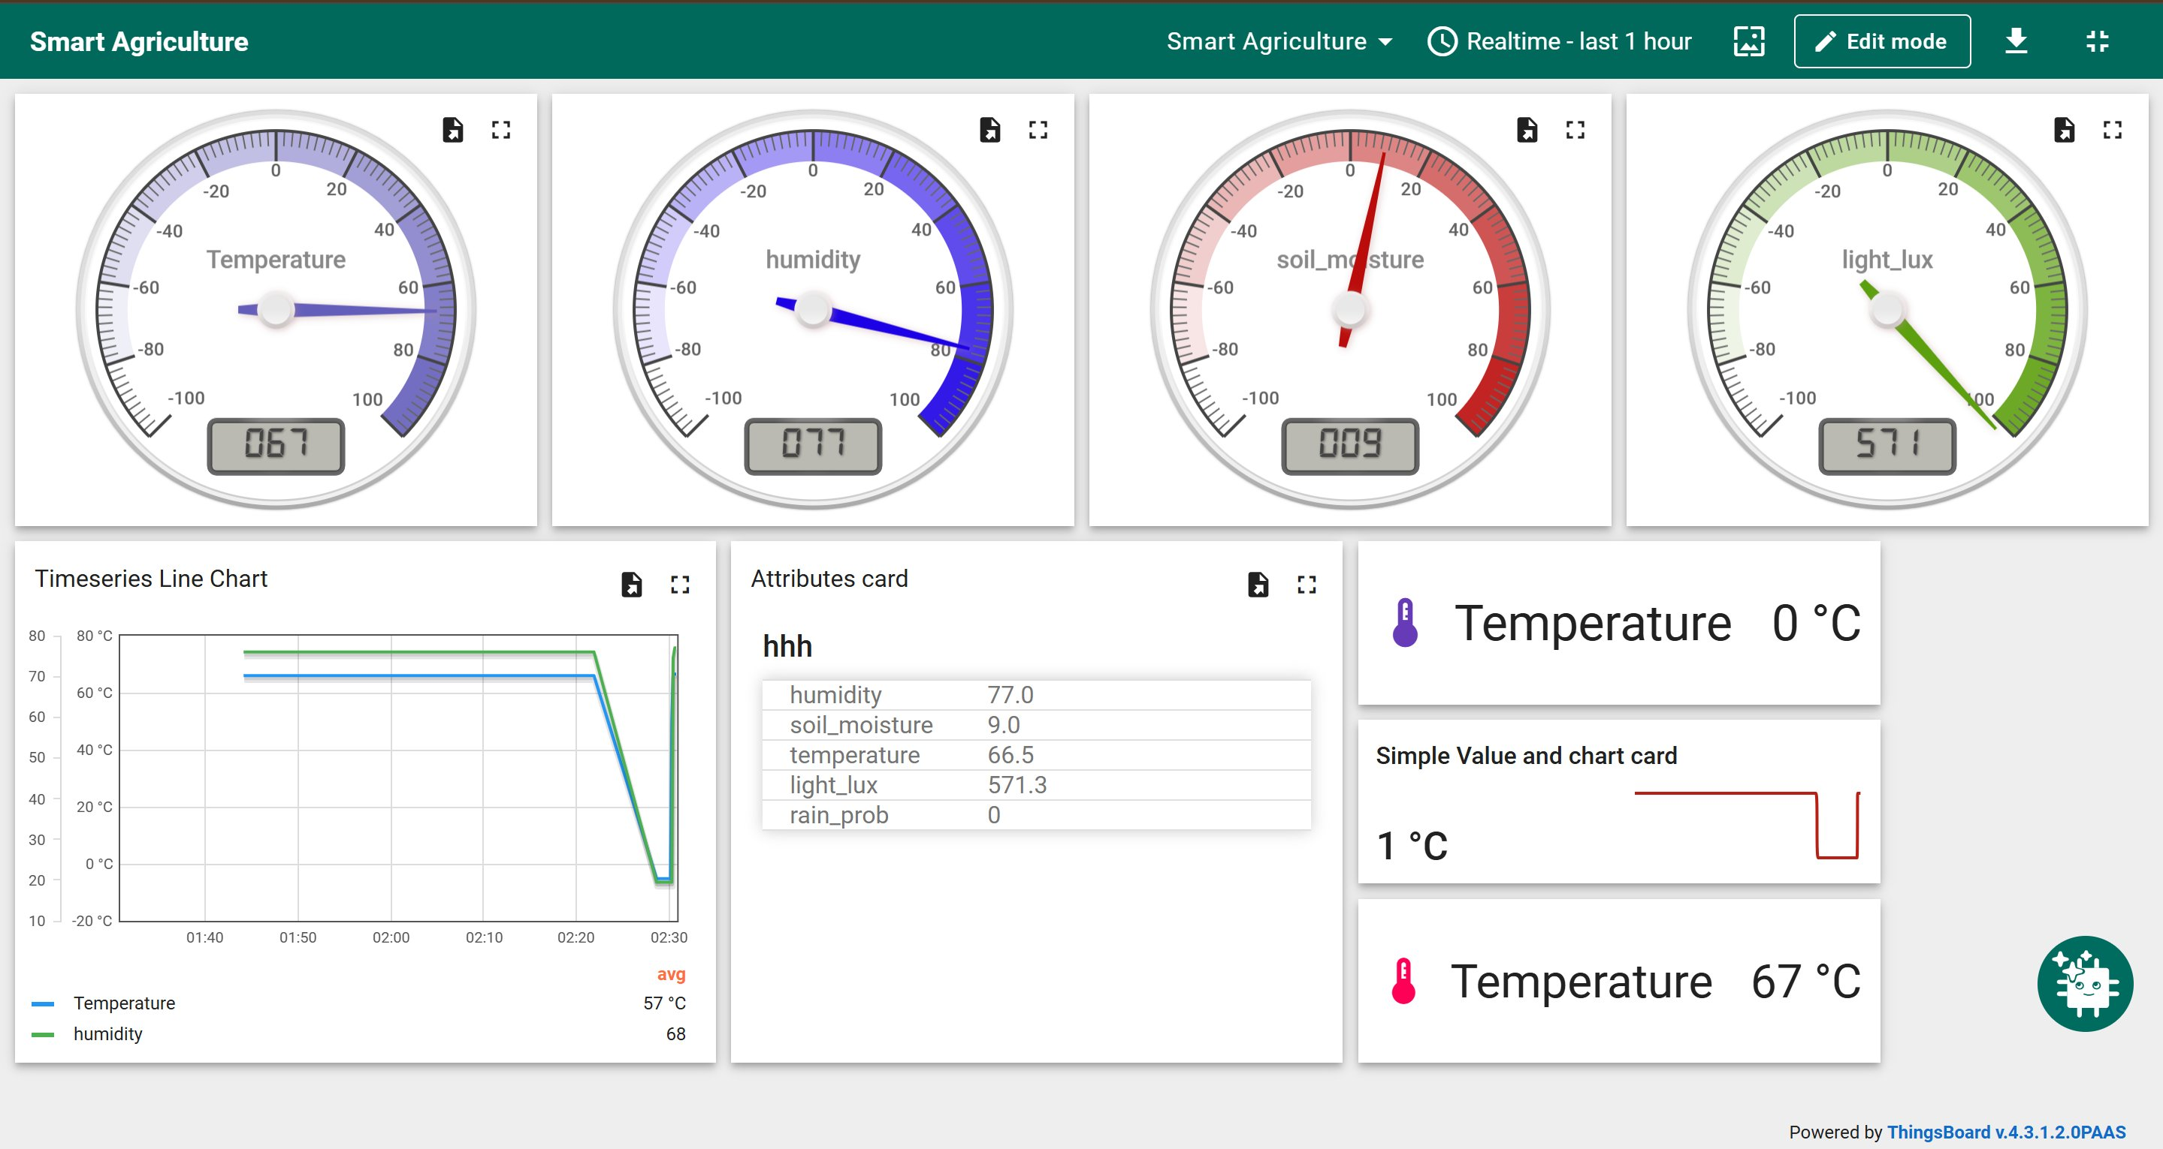
Figure 3. ThingsBoard dashboard showing gauges (Temperature 67, Humidity 77, Soil 9, Light 571), time-series chart, and attributes table with all telemetry keys confirmed.

6. Decision-Making Algorithm
The irrigation logic evaluates soil moisture state and rain forecast on every loop cycle:
- Irrigation ON: soil_moisture > 66.66% (Dry) AND rain_forecast = FALSE → relay HIGH, Telegram 'IRRIGATION STARTED'.
- Predictive Skip: soil_moisture > 66.66% AND rain_forecast = TRUE → relay LOW, Telegram 'PREDICTIVE SKIP -saving water'.
- No Action: soil_moisture ≤ 66.66% (Wet/Normal) → relay LOW.
- Grow-Light: light_lux < 807 → LED ON; else LED OFF.
IF soil_moisture > 66.66 THEN
IF rain_forecast THEN pump = OFF // predictive skip
ELSE pump = ON // irrigate now
ELSE pump = OFF
IF light_lux < 807 THEN led = ON ELSE led = OFF

7. Testing and Results
Testing was conducted in Wokwi, which faithfully emulates the ESP32's ADC, GPIO, I2C, and Wi-Fi interfaces. The DHT22 model was set to 66 °C / 76% RH. The soil moisture potentiometer was manually adjusted between Wet, Normal, and Dry states to validate algorithm branches.
Irrigation Activation Test
When the potentiometer was set to maximum (100% dry), the pump activated immediately. The LCD displayed 'Soil is DRY! Pumping water...' and a Telegram notification 'IRRIGATION STARTED -Soil: 82.0% (Dry)' was dispatched and confirmed with '[TG] Sent OK'.
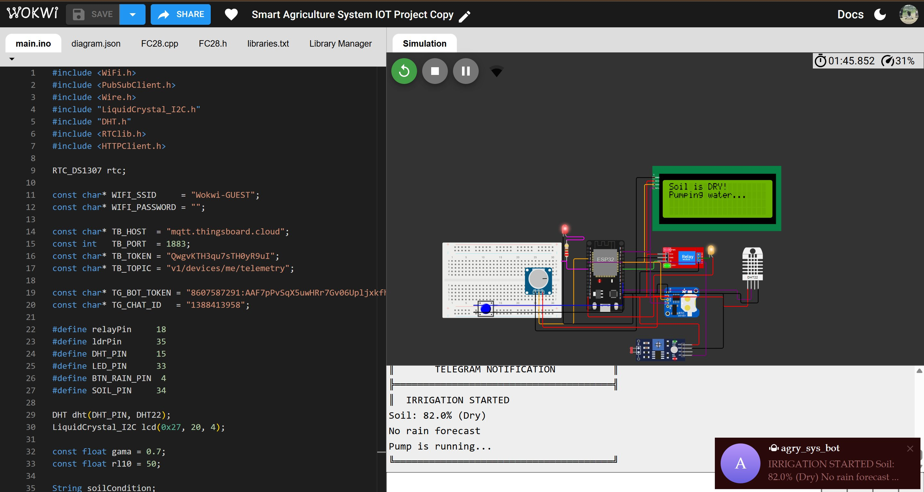
Figure 4. Irrigation activation: LCD shows 'Soil is DRY! Pumping water...', serial monitor displays IRRIGATION STARTED notification, Telegram bot alert visible bottom-right.
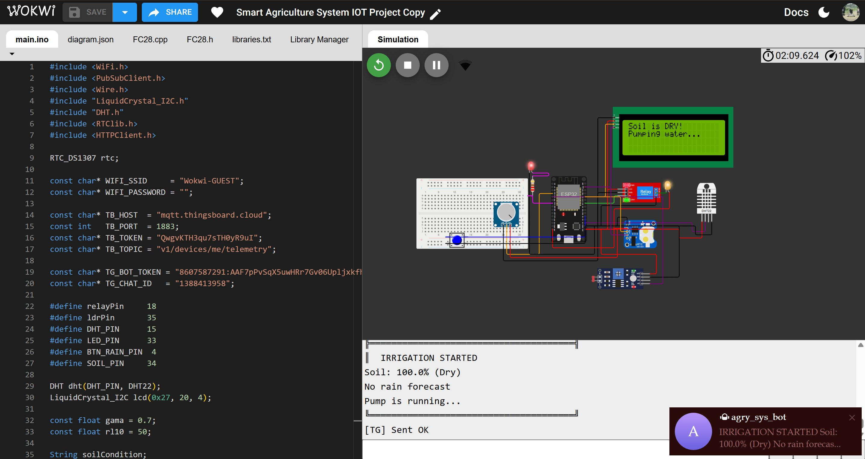
Figure 5. Telegram notification confirmed: '[TG] Sent OK' in serial monitor. Soil: 100% (Dry), No rain forecast, pump running.
ThingsBoard Telemetry Validation
All eight telemetry keys were received and displayed correctly on the ThingsBoard dashboard. The time-series chart showed a clear moisture transition when the potentiometer was adjusted, equivalent to the spike observed in real soil after an irrigation event.
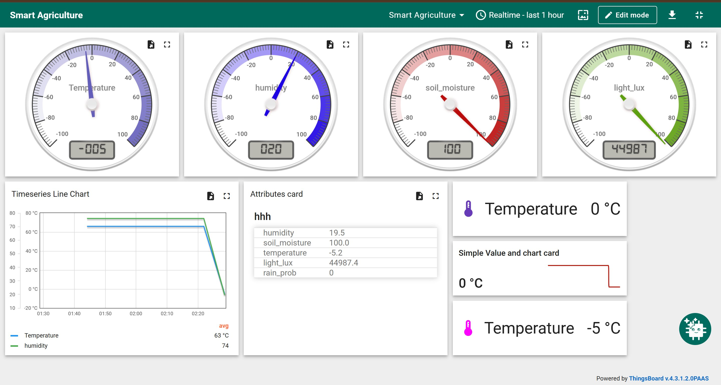
Figure 6. ThingsBoard dashboard during testing: gauges, time-series chart with visible soil moisture change event, and attributes table confirming pump_active and rain_prob values.
Results Summary
Table 2. Test Scenario Results
Test Scenario | Expected Outcome | Result
Normal (wet soil) | Pump OFF, data published | PASS
Dry soil, no rain forecast | Pump ON, Telegram alert sent | PASS
Dry soil, rain forecast ON | Pump OFF, skip alert sent | PASS
Low light | Grow LED activates | PASS
MQTT transmission | All 8 keys in ThingsBoard | PASS
Telegram delivery | [TG] Sent OK in serial monitor | PASS

8. Power Budget Analysis
Table 3. Estimated Power Consumption
Component | Current (approx.) | Notes
ESP32 (Wi-Fi + processing) | 180–250 mA | Peak during MQTT TX
DHT22 + LDR + DS1307 | ~5 mA | Combined sensor load
Relay (coil energised) | 60–90 mA | Active only when pumping
LCD2004 (backlight on) | 20–40 mA | Dominant when relay off
Total (active mode) | ~260–390 mA | Typical monitoring state
Deep Sleep (proposed) | 10–50 µA | Major energy saving

On a 3,000 mAh battery in continuous mode, autonomy is approximately 8–10 hours. Implementing a 5-minute duty cycle with 15-second active periods reduces average draw to ~15–20 mA, extending runtime to 6–10 days. A 6 W solar panel with MPPT charging would provide full energy autonomy under typical Kazakhstan summer conditions (~5.5 peak sun-hours/day).

9. Scalability Analysis
The current single-node prototype can scale in three stages:
- Short term: Multiple ESP32 nodes on a shared Wi-Fi network, each with a unique ThingsBoard access token, publishing to a unified dashboard -viable for greenhouse-scale deployments up to ~1 ha.
- Medium term: Replace Wi-Fi with LoRaWAN (Semtech SX1276) for kilometre-range, low-power coverage -suitable for open field deployment across Kazakhstan's steppe regions. LoRaWAN Class A devices achieve battery lifetimes of 5–10 years (Zhang et al., 2010).
- Long term: TinyML crop models on ESP32 (TensorFlow Lite for Microcontrollers), weather API integration, solar-powered nodes, and satellite imagery via Farmonaut NDVI API -supporting national Digital Agriculture 2030 objectives (Baydildina et al., 2020).

10. Conclusion
AquaGuard successfully demonstrates how affordable ESP32-based IoT technology can deliver automated, data-driven irrigation management. All project objectives were met: real-time sensor telemetry is collected, transmitted to ThingsBoard, and used by a rule-based algorithm to control irrigation while conserving water through a predictive rain-forecast feature. All six test scenarios passed. The modular architecture provides a credible pathway from this single-node prototype to a full-scale LoRaWAN field deployment, directly supporting Kazakhstan's precision agriculture goals.

References
PRECISION AGRICULTURE IN THE NORTH OF KAZAKHSTAN
https://dspace.emu.ee/server/api/core/bitstreams/63098878-80d2-4067-9325-ad21370ab53a/content
Precision Agriculture Monitoring System Using Green Internet of Things (G-IoT). (2018, May 1). IEEE Conference Publication | IEEE Xplore. https://ieeexplore.ieee.org/abstract/document/8553866
The realization of precision agriculture monitoring system based on wireless sensor network. (2010, June 1). IEEE Conference Publication | IEEE Xplore. https://ieeexplore.ieee.org/abstract/document/5544354

